Name:  Teacher: | ___________________________________________  ___________________________ |  | Date:___________
 | Year 9 Mathematics  SCORE:  / 35  Topic – Trigonometry  Working out MUST BE SHOWN for full marks
Total Time: | 45 minutes
Weighting: | 6 %
Equipment: | To be provided by the student:  Pens and Pencils, scientific calculator, ruler and an A4 page of notes.

Multiple choice questions 6 marks

Question 1. Which statement is true for the angle θ in the diagram?  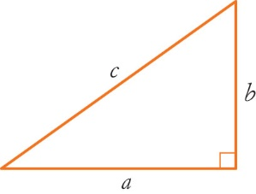  - b = opposite  - b = adjacent  - c = adjacent  $$θ$$  - a = opposite | Question 2. What is the length of the adjacent side when considering the 20$°$ angle?  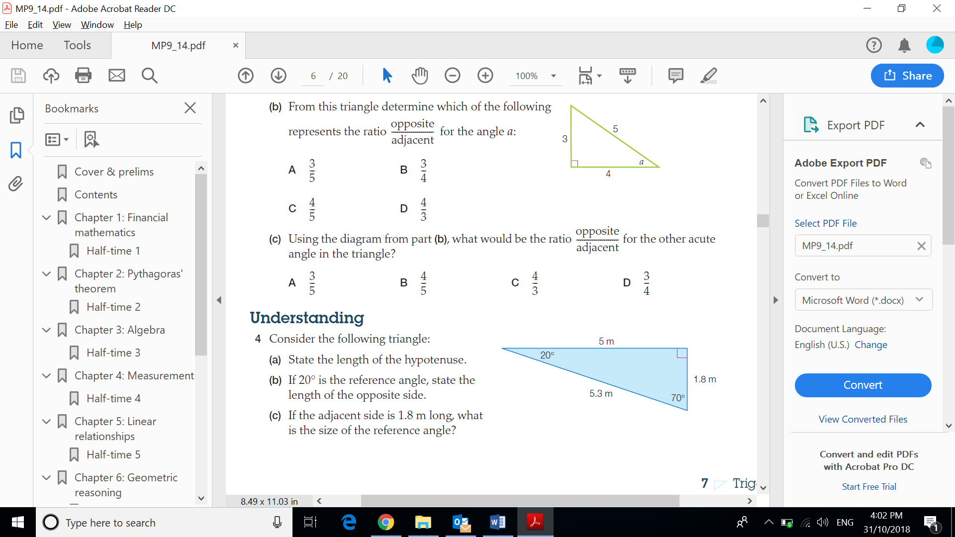  - 20 m  - 5 m  - 1.8 m  - 5.3 m
Question 3. What is the ratio for Sine?  - $\frac{HYP}{OPP}$  - $\frac{OPP}{ADJ}$  - $\frac{OPP}{HYP}$  - $\frac{ADJ}{OPP}$ | 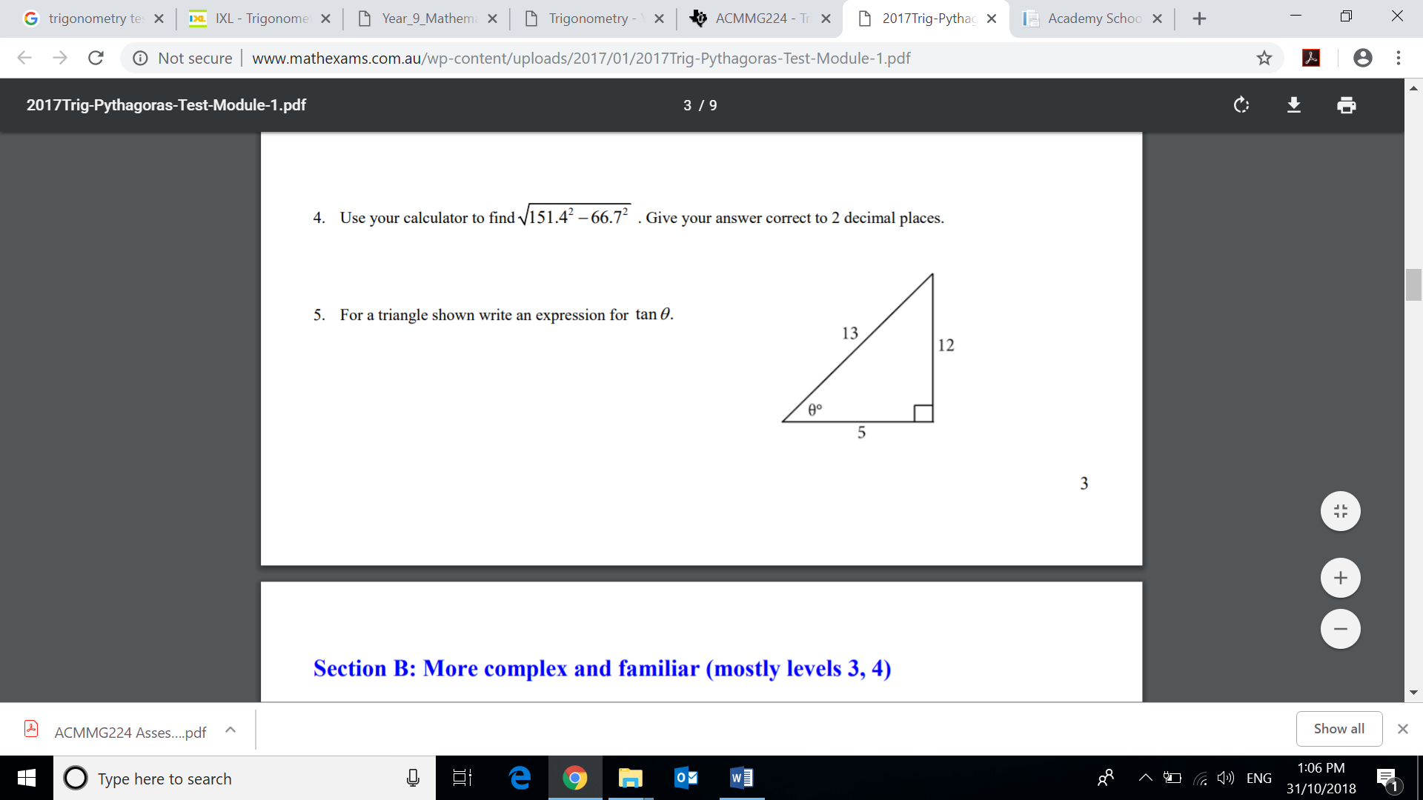  Question 4. Which is the correct ratio for $\tan{θ}$  - $tan θ=\frac{13}{12}$  - $tan θ=\frac{5}{12}$  - $tan θ=\frac{5}{13}$  - $tan θ=\frac{12}{5}$
Question 5. Which of the following is a Pythagorean triple?  - (1, 2, 3)  - (4, 5, 6)  - (5, 12, 13)  - (15, 20, 30) | Question 6. Which ratio would you use to determine the value of x?  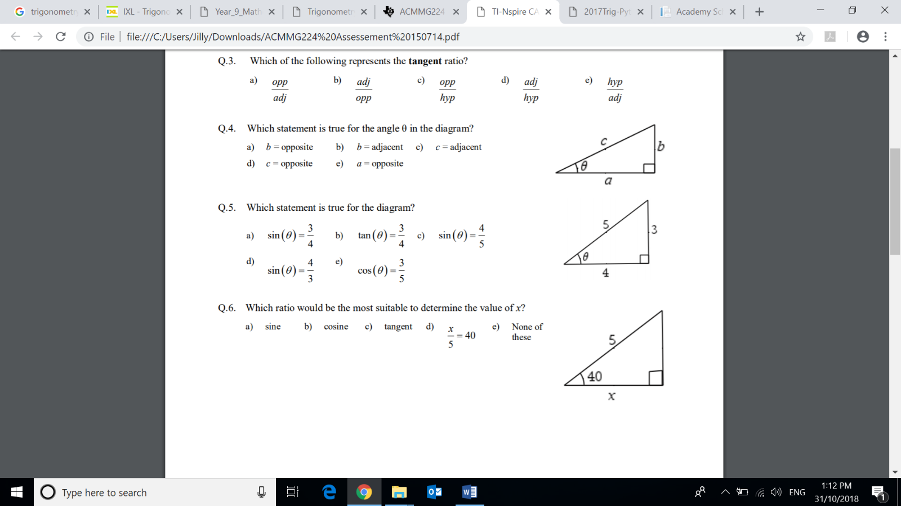  - sine  - cosine  - tangent  - $\frac{x}{5}=40$
Short answer questions 29 marks
Show FULL working out to get FULL marks

Question 7. Calculate the lengths of the sides marked with letters in each of the following triangles, giving your answers to 1 decimal place. [8 marks]

a.  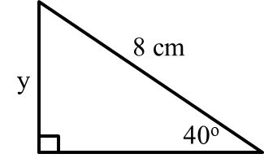 | 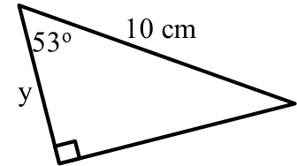  b.
c.  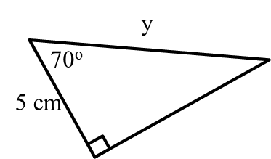 | d.  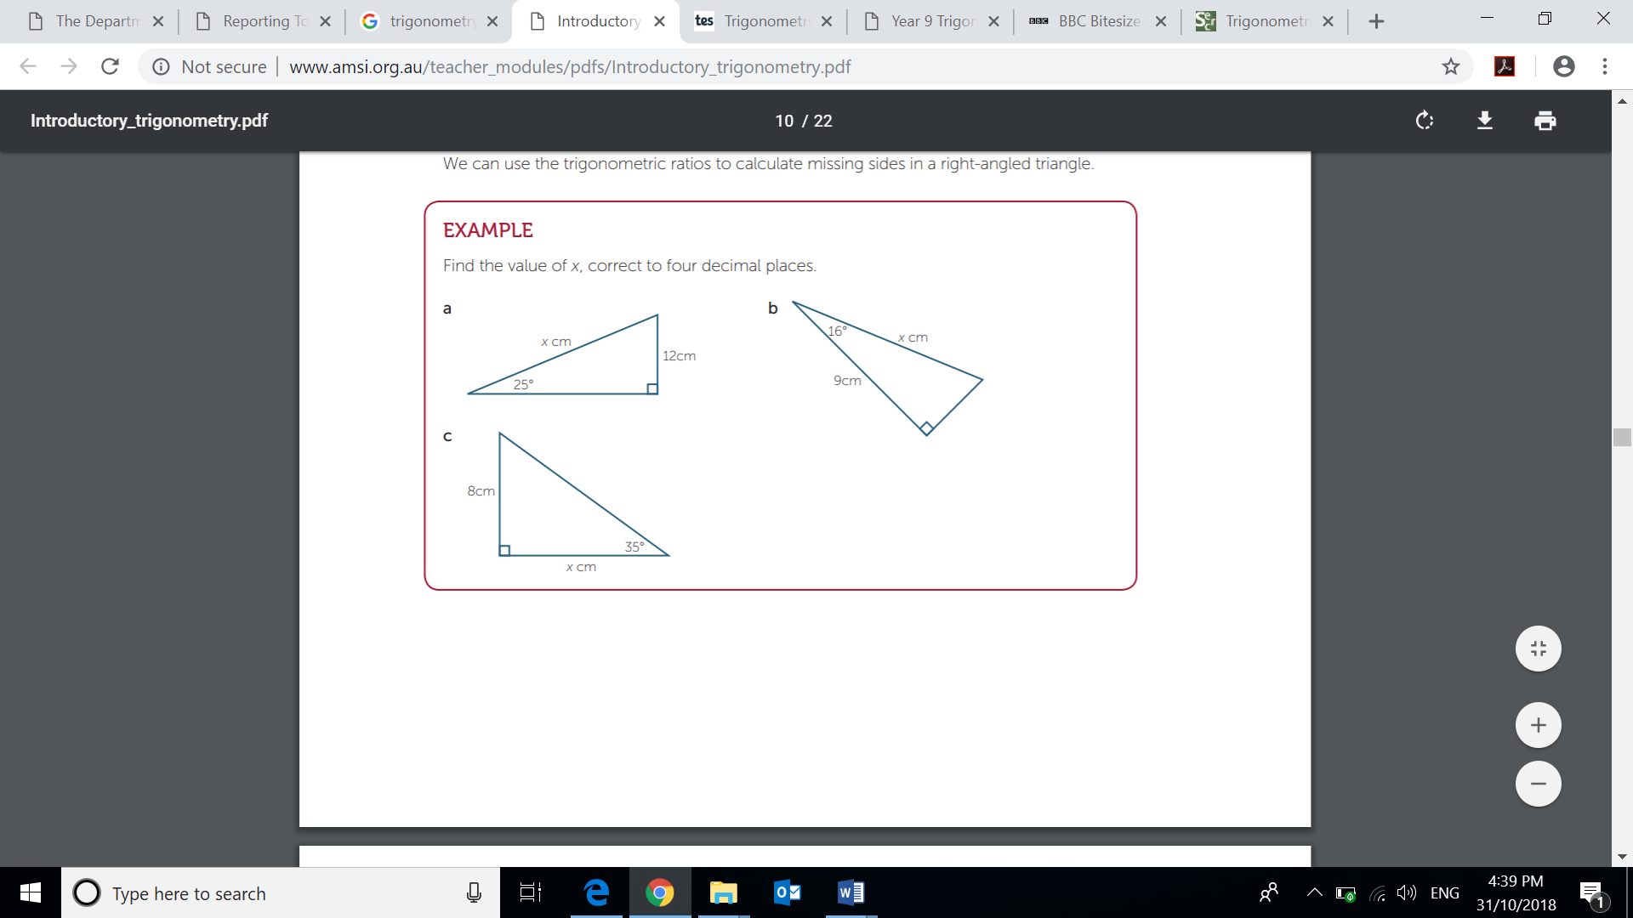

Question 8. Calculate the size of each of the angles marked θ in the following triangles, giving your answers to the nearest degree. [4 marks]

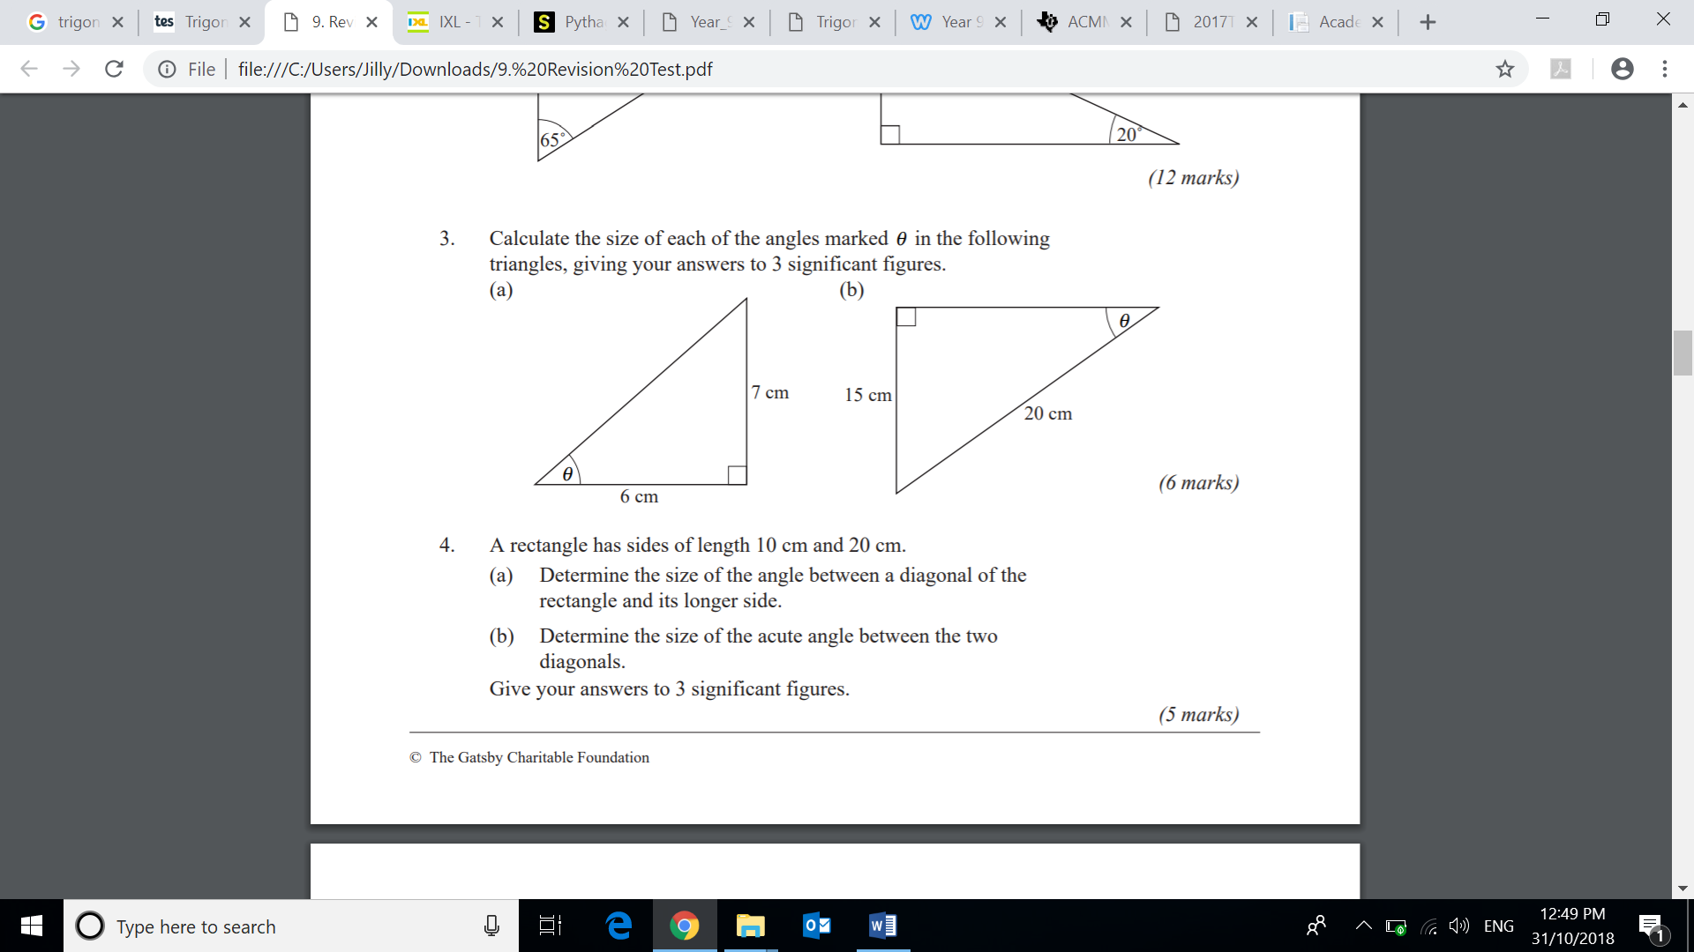 | 
Question 9. Two ladders are resting at the top of a wall. The shorter ladder is 8m long and its bottom end is 4m from the base of the wall. The end of the longer ladder is 5m from the end of the shorter ladder on the ground. How long is the longer ladder to the nearest metre? [5 marks]

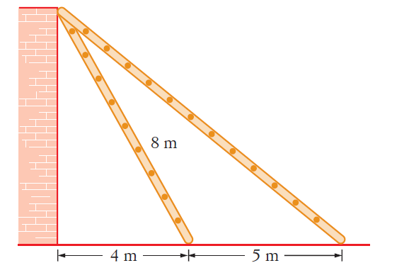

Question 10. A children’s slide has a length of 5.8m and makes an angle of $38°$ with the vertical ladder that is 2.5m high. [3 marks]

- Draw a diagram showing the information provided

- Find the angle the slide makes with the ground.

Question 11. A square has diagonals of length 6 cm. Find the length of its sides, correct to 2 decimal places. [3 Marks]

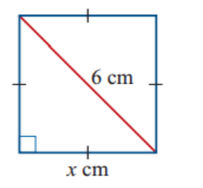

Question 12. The following answers were given on a trigonometry test. [6 marks]

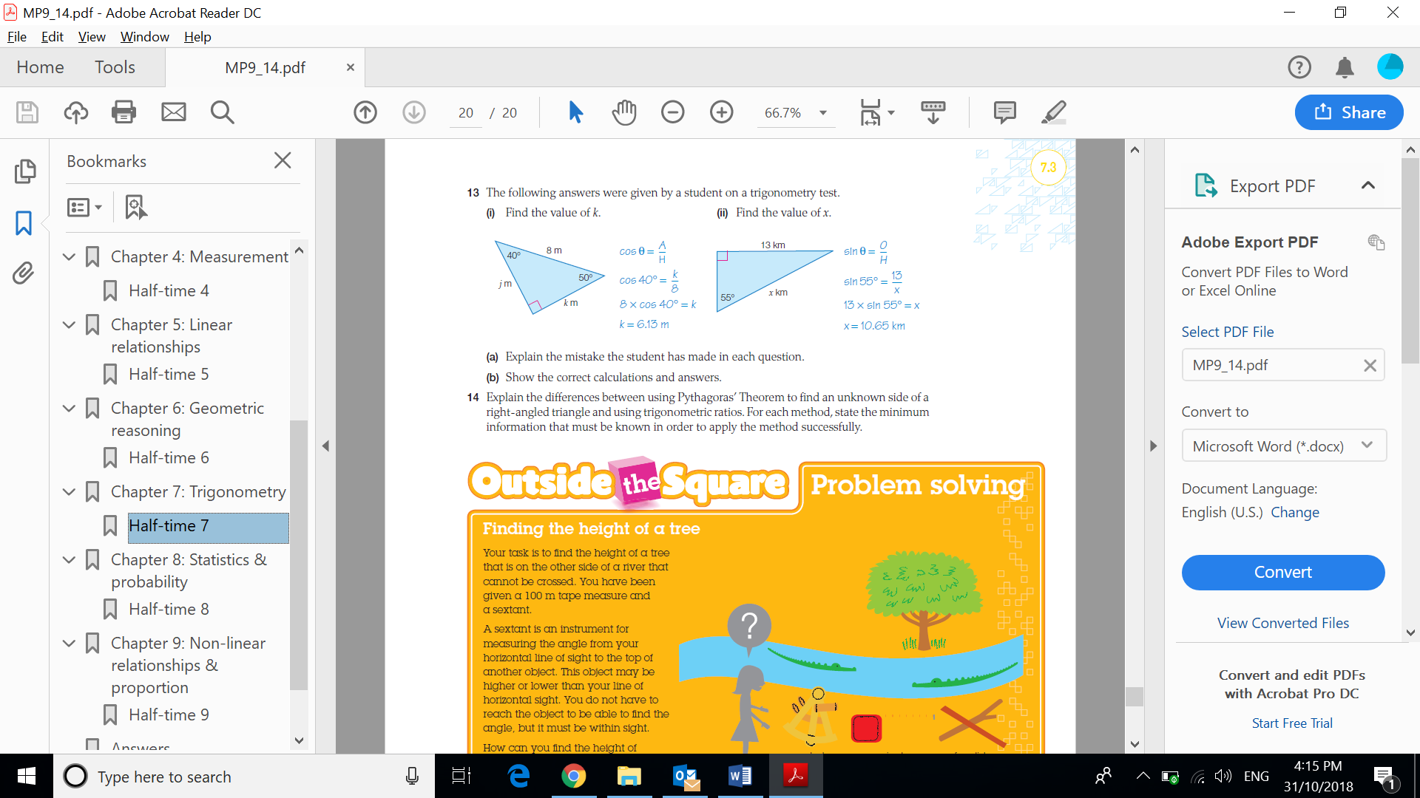 | 
a. What mistake did this student make? | a. What mistake did this student make?
b. Show the correct calculations and answers for the question above | b. Show the correct calculations and answers for the question above

END OF TEST

